Functional Interfaces In Java

A functional interface is an interface that contains only one abstract method.

lambda expressionscan be used to represent the instance of a functional interface

A functional interface can have any number of default methods. Runnable, ActionListener, Comparable are some of the examples of functional interfaces.

// Java program to demonstrate functional interface

class Test
{
public static void main(String args[])
{
// create anonymous inner class object
new Thread(new Runnable()
{
@Override
public void run()
{
System.out.println("New thread created");
}
}).start();
}
}

Java forEach loop

Java provides a new method forEach() to iterate the elements.

It is defined in Iterable and Stream interface. It is a default method defined in the Iterable interface. Collection classes which extends Iterable interface can use forEach loop to iterate elements.

This method takes a single parameter which is a functional interface. So, you can pass lambda expression as an argument.

public static void main(String[] args) {
List<String> gamesList = new ArrayList<String>();
gamesList.add("Football");
gamesList.add("Cricket");
gamesList.add("Chess");
gamesList.add("Hocky");

gamesList.forEach(games -> System.out.println(games));

gamesList.forEach(System.out::println);

}

Lambda Expressions in Java 8

Lambda expressions basically express instances of functional interfaces (An interface with single abstract method is called functional interface. An example is java.lang.Runnable). lambda expressions implement the only abstract function and therefore implement functional interfaces

lambda expressions are added in Java 8 and provide below functionalities.
- Enable to treat functionality as a method argument, or code as data.
- A function that can be created without belonging to any class.
- A lambda expression can be passed around as if it was an object and executed on demand.

@FunctionalInterface
public interface Square {
abstract int caluclate(int x);

}

public class Hi {

public static void main(String[] args) {

// lambda expression to define the calculate method
Square s=(int x) ->x*x;

// parameter passed and return type must be
// same as defined in t
int ans= s.caluclate(2);
System.out.println(ans);

}

}

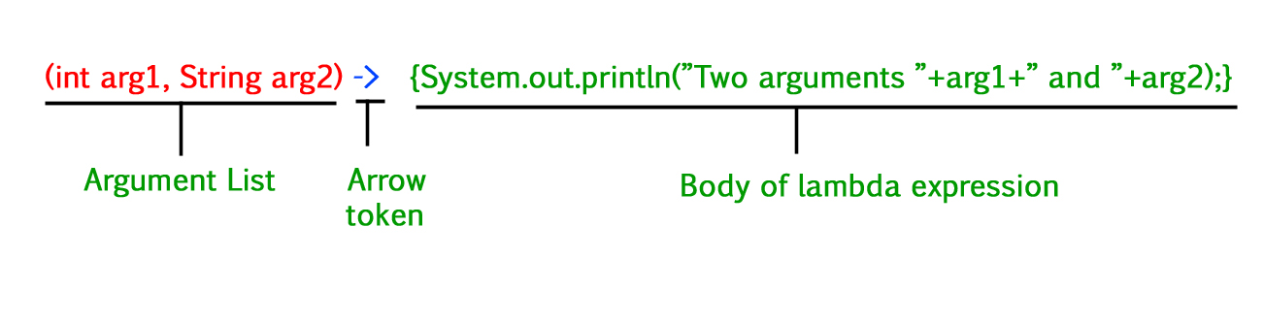

Syntax:
lambda operator -> body

Zero parameter:
() -> System.out.println("Zero parameter lambda");

One parameter:–
(p) -> System.out.println("One parameter: " + p);
It is not mandatory to use parentheses, if the type of that variable can be inferred from the context
Multiple parameters :
(p1, p2) -> System.out.println("Multiple parameters: " + p1 + ", " + p2);

Please note: Lambda expressions are just like functions and they accept parameters just like functions.

java.util.function Package:

The java.util.function package in Java 8 contains many builtin functional interfaces like-

Predicate:
- The Predicate interface has an abstract
- method test which gives a Boolean value as a result for the specified argument. is

